Yusuf Anı, email : [ge83reb@mytum.de](mailto:%67%65%38%33%72e%62@m%79t%75%6d.%64%65)

**Question-1**

1. I have opened the dataset and used volume rendering for direct volume rendering. This dataset contains scalar(color and surface information of the head), vector data (3D mesh of vertices) and tensor data( internal structure of the head) types. I opened the shading option to visualize more realistically.

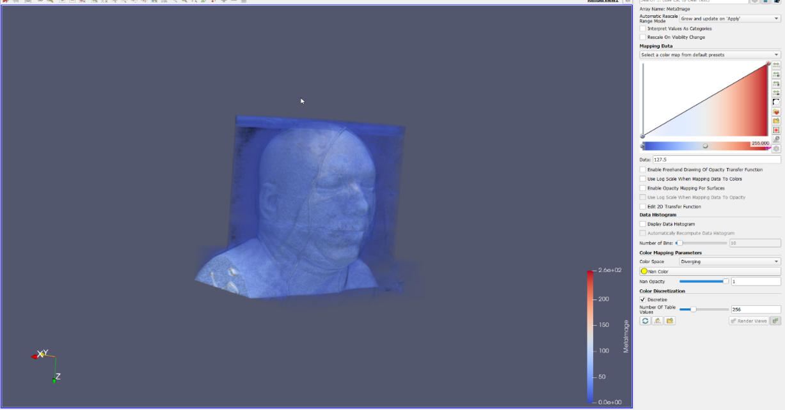

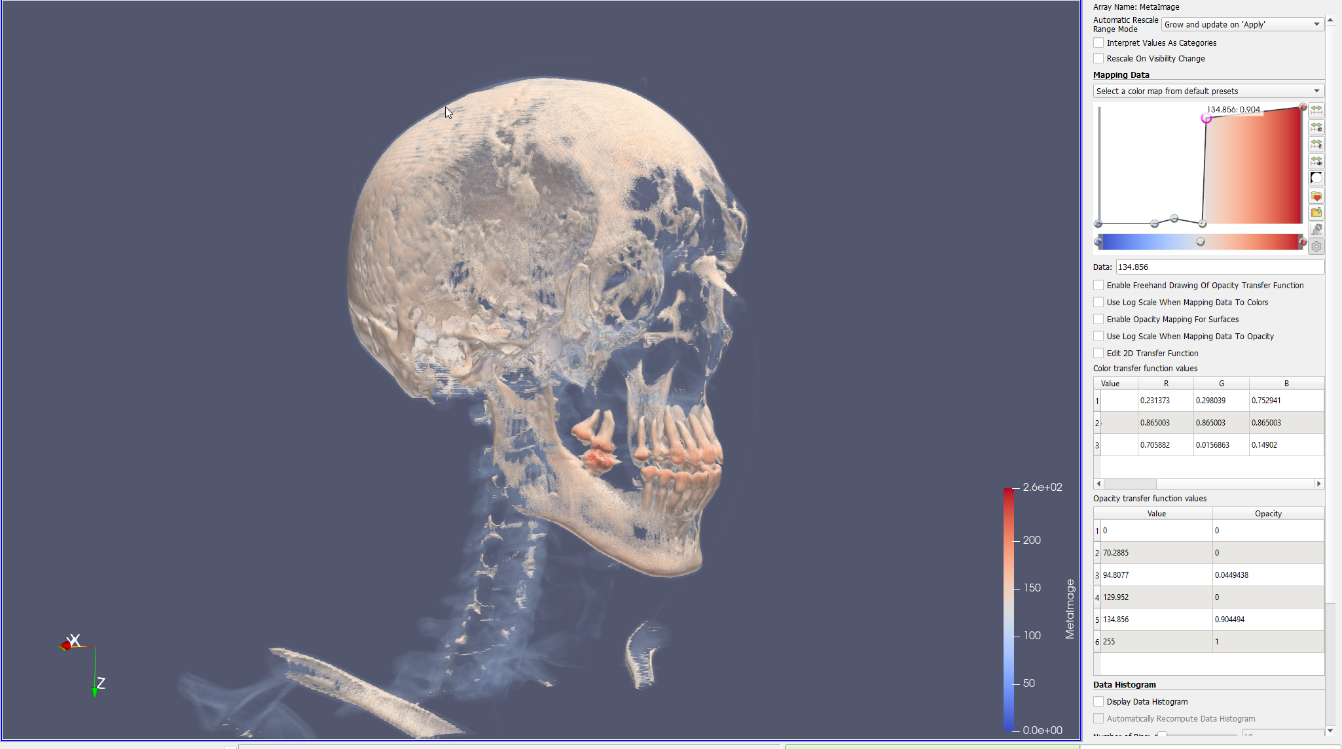

By manipulating the transfer function, I extracted the human face skeleton in the dataset. Basically, I eliminated low density values like air and skin to see more density values. I made some low values visible to give insight into the body. As you can see, the teeth stand out most intensely.

1. I downloaded the Asian dragon and loaded it into ParaView. This is Polygonal Mesh data. The Asian Dragon model file contains a 3D scan of a dragon sculpture, and the data file contains information about the geometry of the model such as the vertices, edges, and faces that make up the 3D mesh, as well as potentially textures and other material information. I also used a clip for to see the inside of the dragon.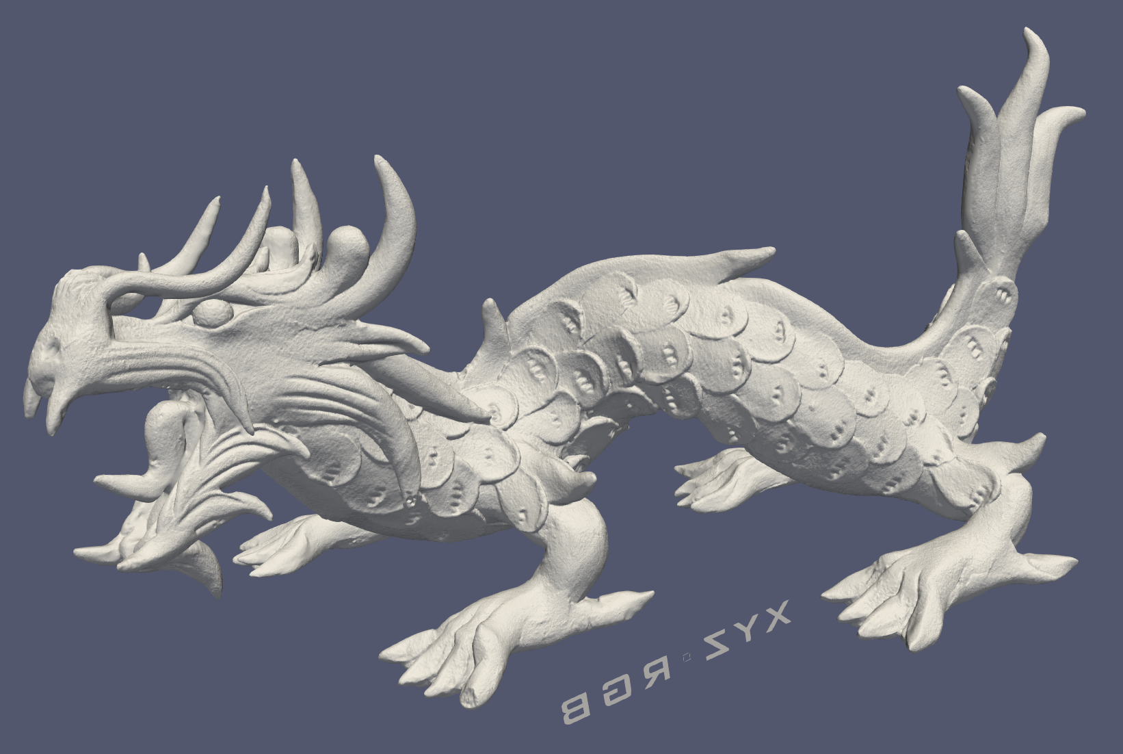 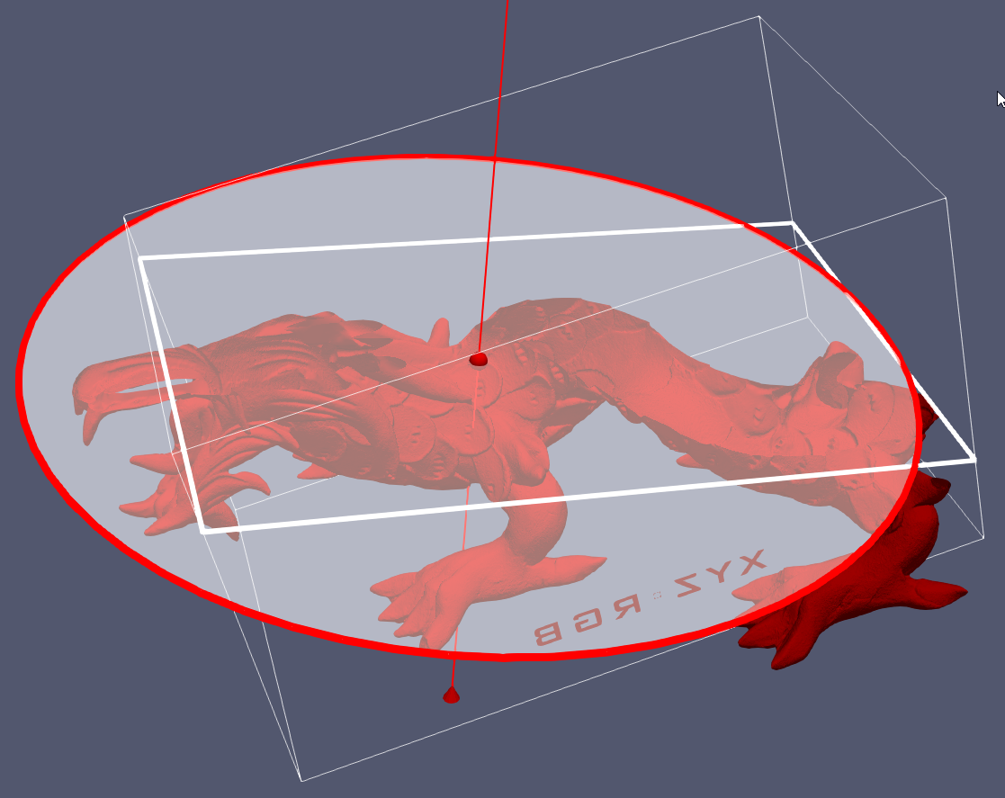
2. I used one of the default examples (Fig1) in ParaView to visualize via particle tracing and streamlines. To do that, I selected the Velocity stream of the object. It seems too complex to see all in the figure (Fig2), so I took a seed point cloud inside the object and made a pipe of streamlines (Fig3). I also added the direction of streamlines (Fig4 and Fig5). This dataset contains vector data. 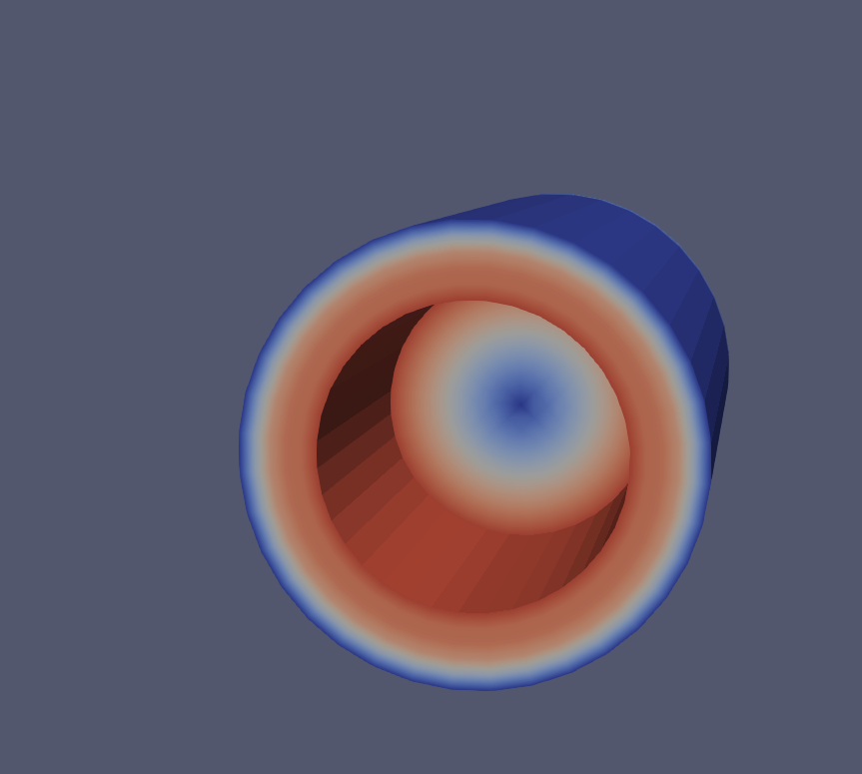 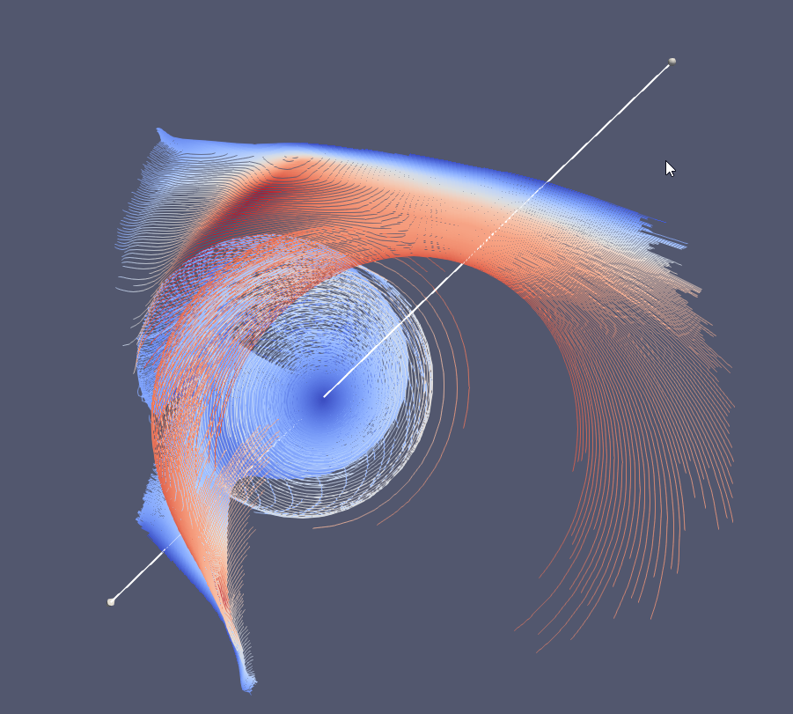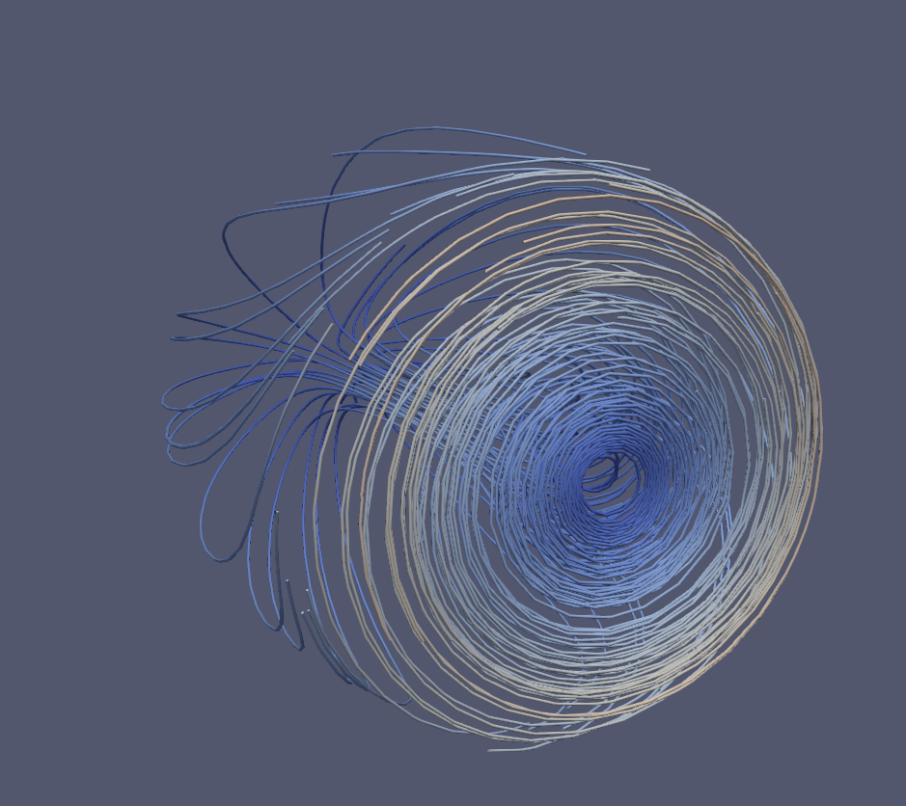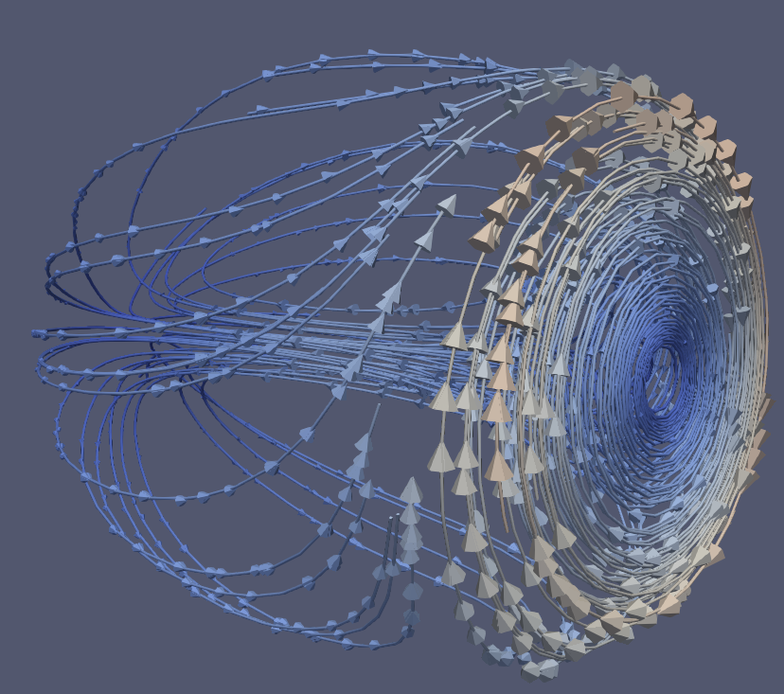 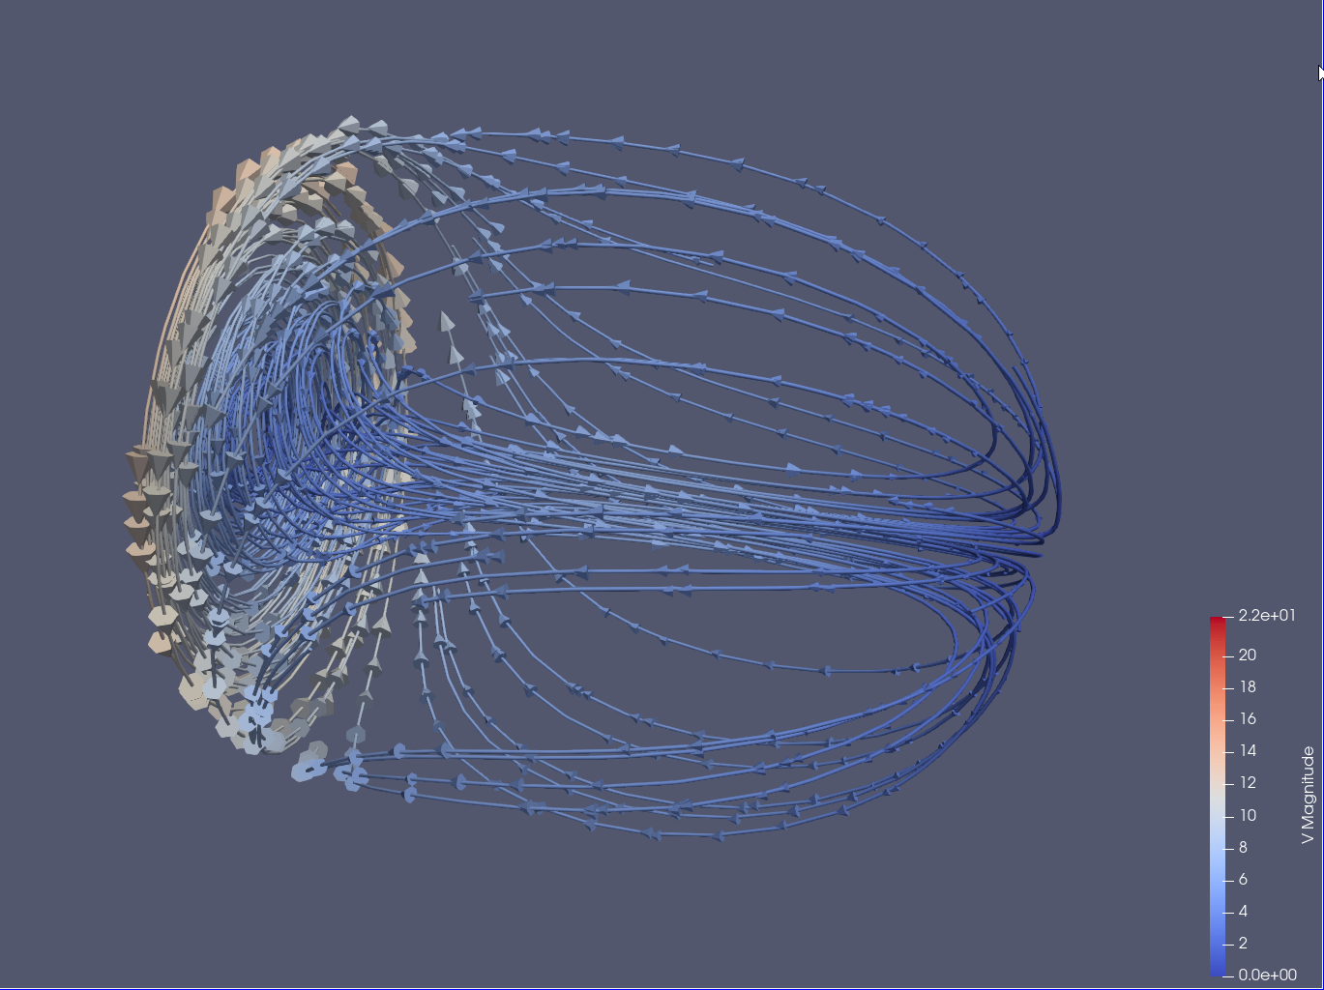

For particle tracing, I used fluid flow in a pipe. For this, I created points as a seed. Then I added a particle tracking filter to follow the velocity of the liquid. I also added a glyph to increase the scaling factor of the point for visualization purposes. I have added some screenshots. This dataset contains vector data.

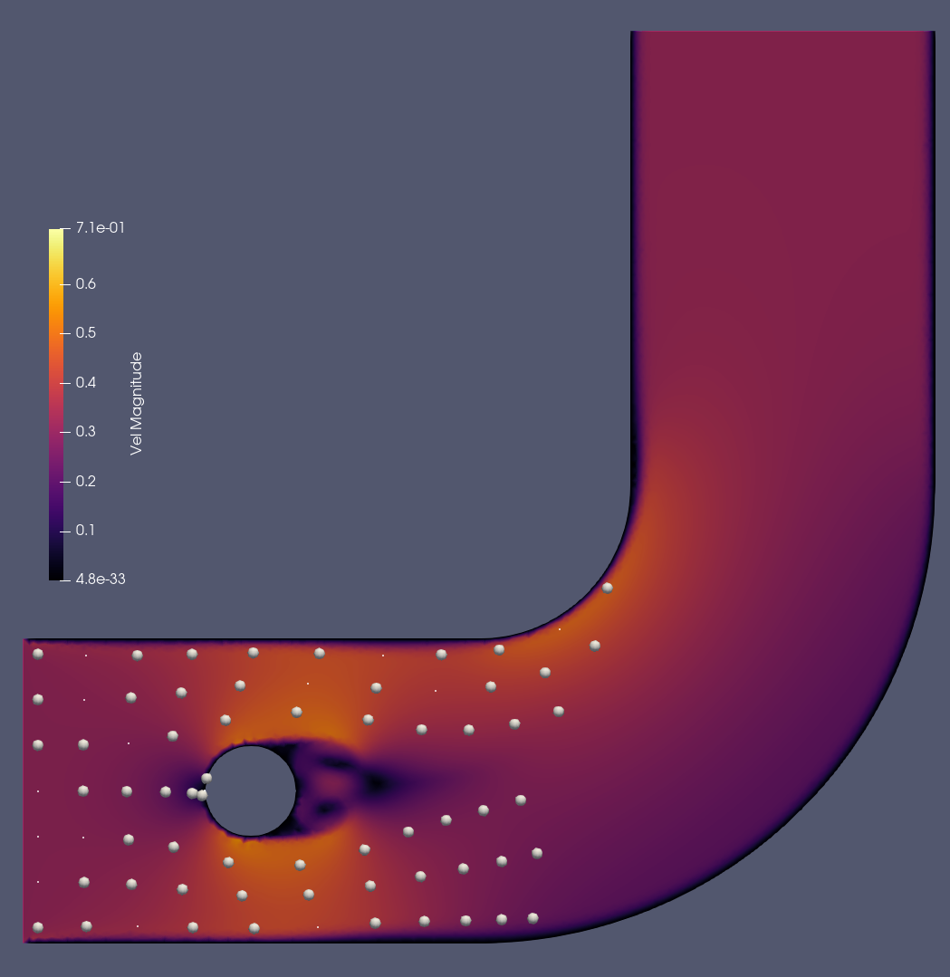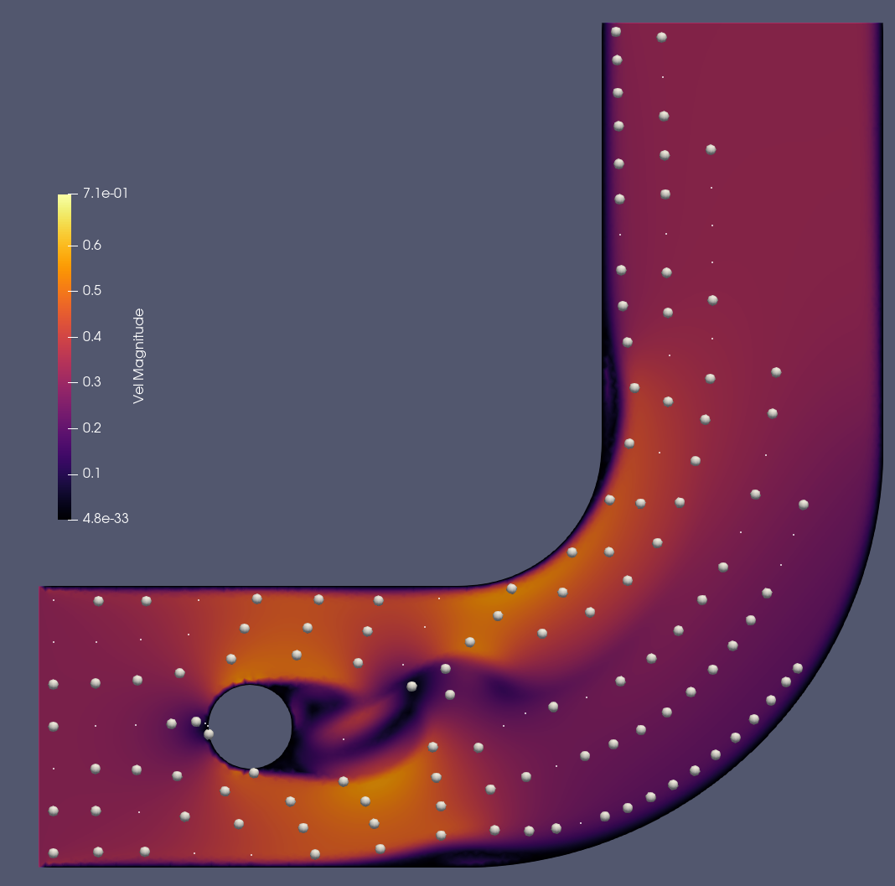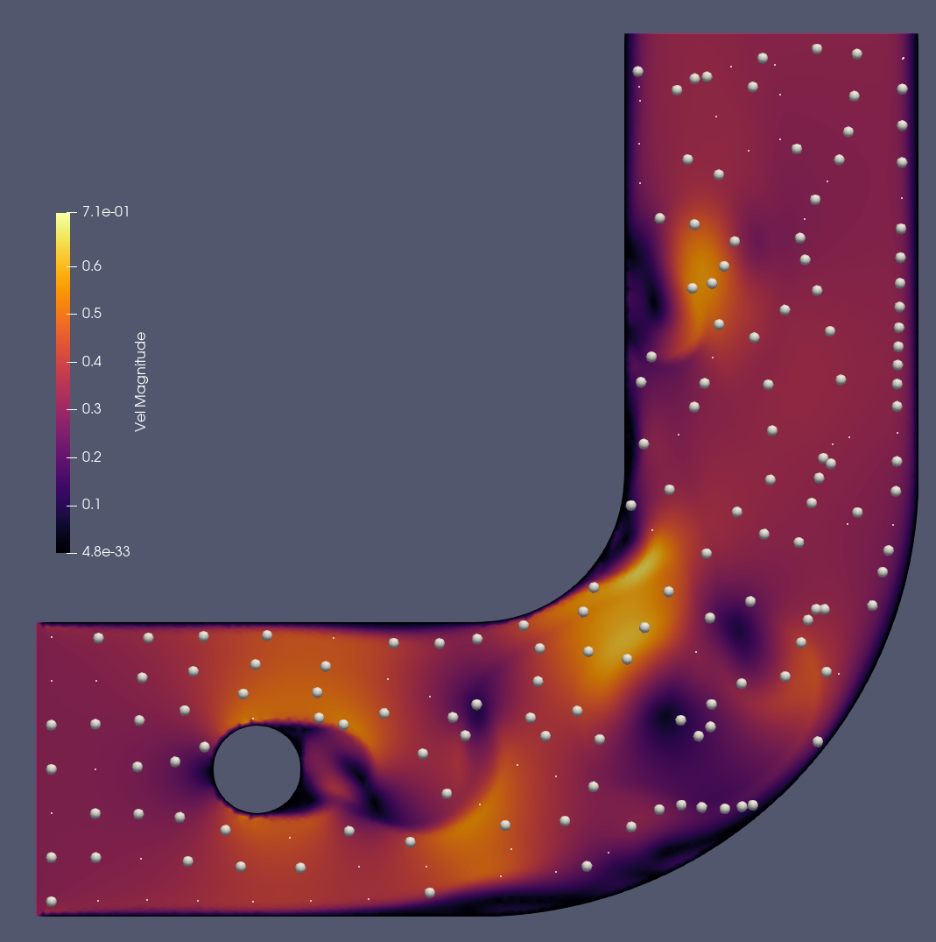

d-) I downloaded a protein called 6IZX. In the online 3D viewer, DNA can be seen easily because each helix has a different color. They also showed two other structures in green and orange colors by connecting them spirally to each other. In my visualization, the DNA can be seen easily, but the other structures are not. It seems that the pipes are not nice about the shapes and connecting the dots. This dataset contains categorical data like types of moleculs, scalar data like tempatures, vector data like 3D structure of the molecule.

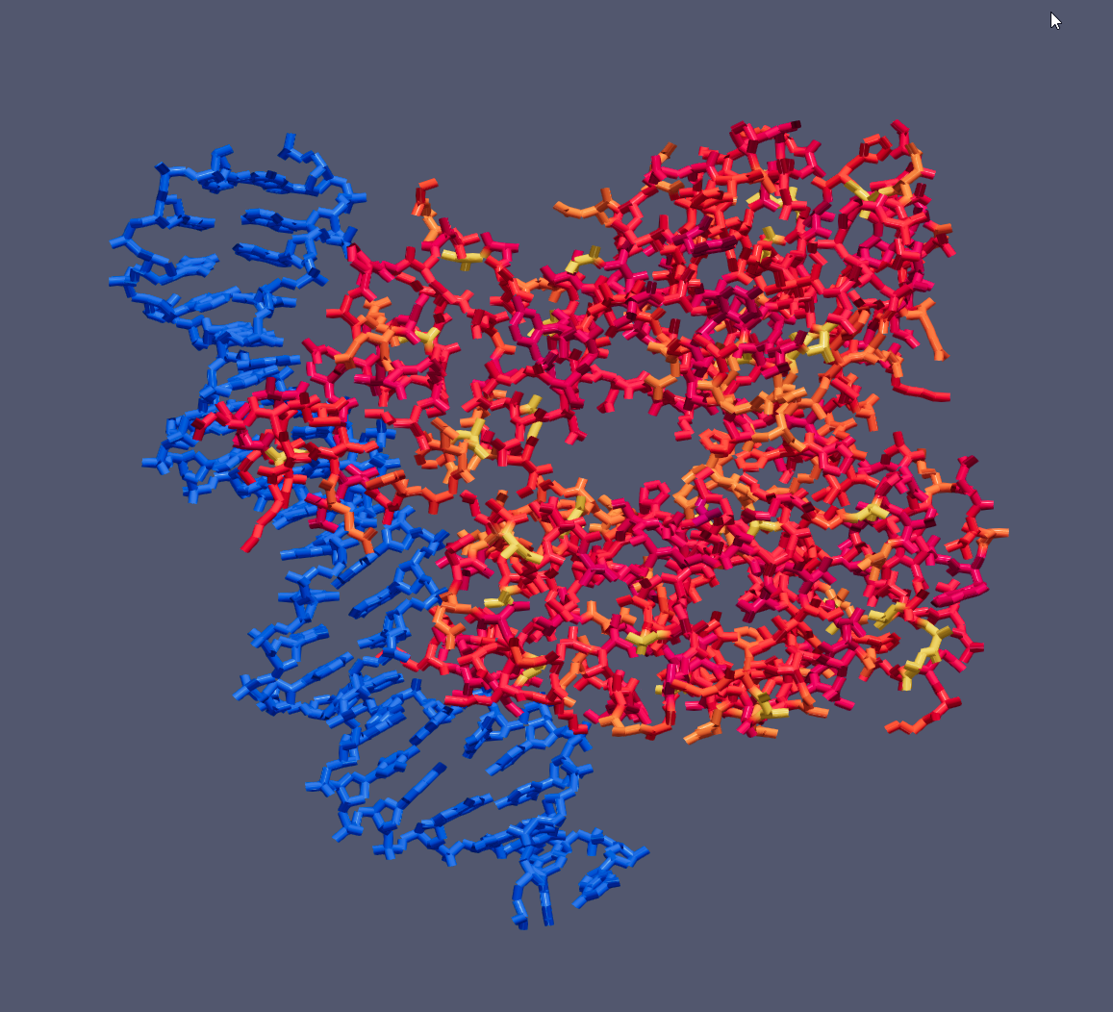

Question-2: I have selected Tableau option because I have heard more than another tool.

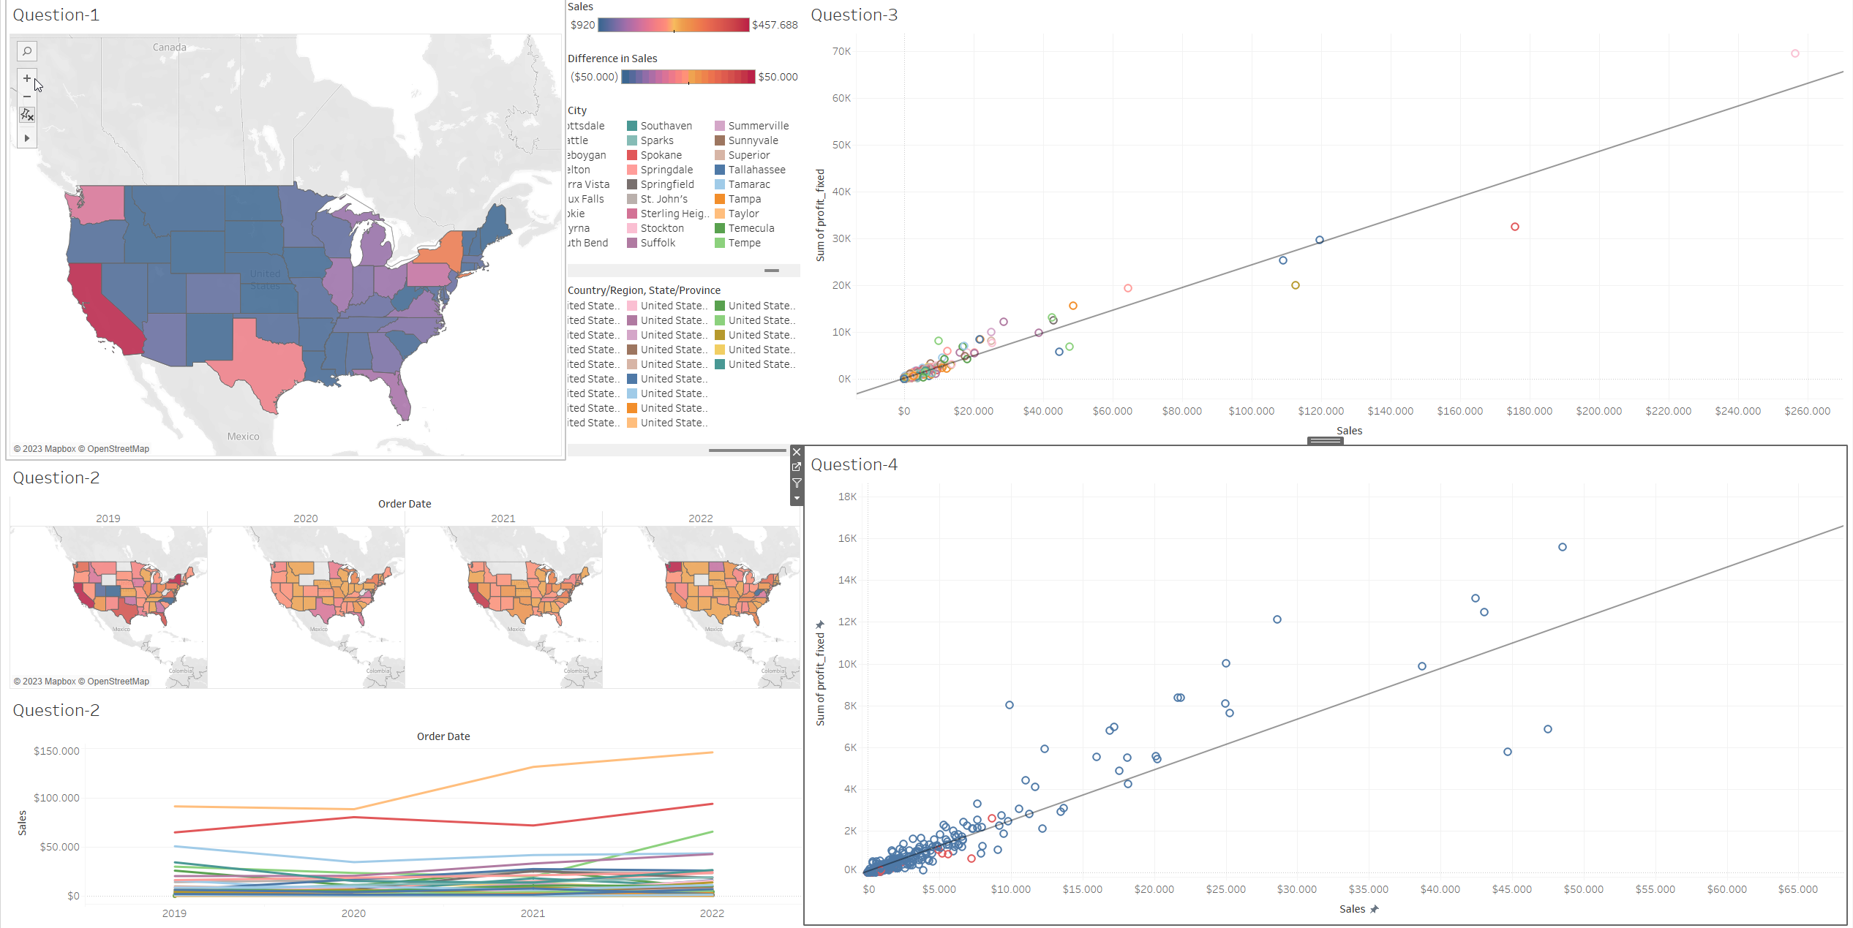

This dataset contains categorical data like state names and scalar data like sale counts.

a-) For the first question, we need to group total sales by US states. So, we had geographic data and numeric data. To do this, I created a filter on the Country column and set only US. Then I dragged the sales column to color marks. Since we need to visualize data on geographic data, we could give corresponding color to each state by total sales. I edited the color filter and gave the following color scheme.

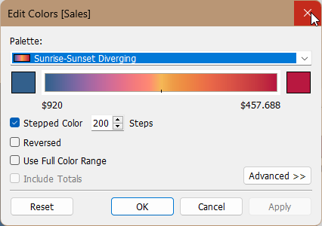

Basically, Blue is low total sales and red is high total sales. As you can see from the above figure, even if some outliers exist, neighbor states have the same or nearby colors. So we can say there is a pattern between total sales and geographical location in US states.

b-) To see the development over time, we need to find the difference in sales over time. As a time indicator, I selected the year of the order. Then, I calculated the sales difference by year. I also took a range from -50,000 to +50,000 as color range coding since we are visualizing the difference.

2019 is our start year, so we don’t have a real difference. Also, there are some missing values in all years. When we look at the data pattern, it is not clear as in the previous question, but I still see a relation. For example, we do not see blue or red suddenly.

c-) I created a scatter plot to describe the correlation between sales and profit. Also, for each city, I used color coding. To visualize the correlation between two variables, I used a linear trend.

Note: I have discovered wrong values in dataset and fixed them :D Check profit and profit_fixed

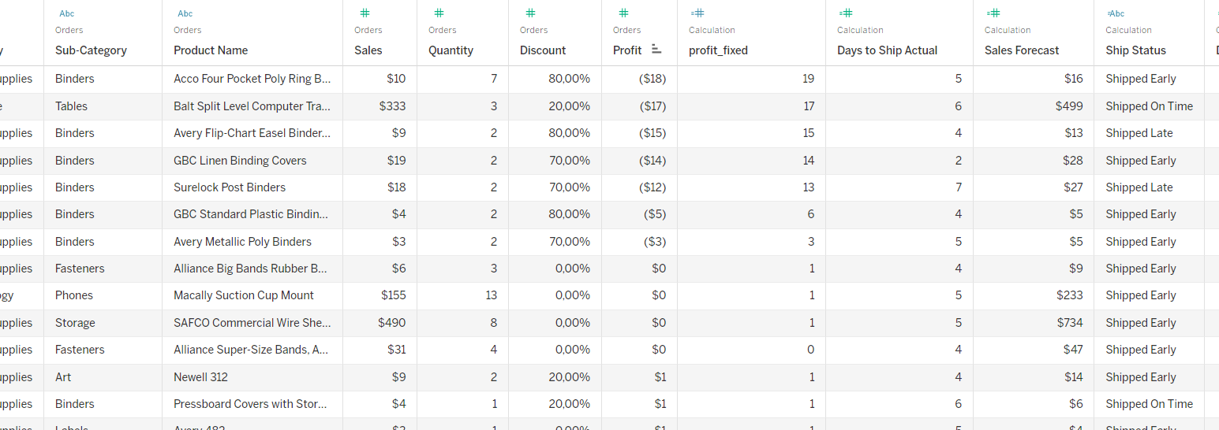

d-) To visualize profit/sale in Florida and other state's cities, again I applied color coding. I put a red color on Florida cities and blue color on other cities. By looking at the figure, I can say that Florida cities' sales have a high profit margin, but they are still close to the trend. I also implemented brushing, when I select Florida state, I have only seen information about Florida.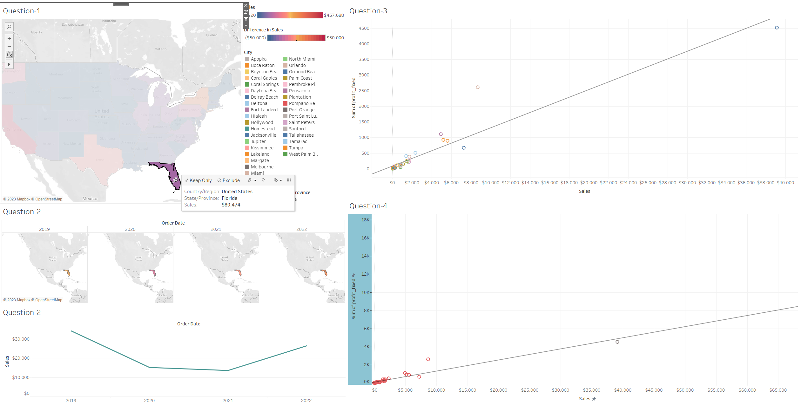

In summary, I have used ParaView to visualize different data sets such as the VisHuman Head, Asian Dragon, vector data and pdb files. I have used different visualization techniques such as clipping planes, transfer functions, color tables, and iso-surfaces. I have also used Tableau Desktop to analyze the Superstore Sales data set and create visualizations that answer specific analysis questions related to the data. The data that I have used in this exercise is the VisHuman Head, Asian Dragon, vector data, pdb files and Superstore Sales data set.

Overall, the exercise has been a great opportunity for me to gain practical experience with different visualization tools and to learn how to use them to analyze and understand data. It has helped me to understand the importance of visualizing data in order to gain insights and make better-informed decisions.